6 - Efetuar os seguintes exercícios do Addressing Subnet Work book: Pág. 5, 6, 7, 13 e 16
Pág. 5
177.100.18.4: 255.255.0.0
119.18.45.0: 255.0.0.0
191.249.234.191: 255.255.0.0
223.23.223.109 255.255.255.0
10.10.250.1 255.0.0.0
126.123.23.1 255.0.0.0
223.69.230.250 255.255.255.0
192.12.35.105 255.255.255.0
77.251.200.51 255.0.0.0
189.210.50.1 255.255.0.0
88.45.65.35 255.0.0.0
128.212.250.254 255.255.0.0
193.100.77.83 255.255.255.0
125.125.250.1 255.0.0.0
1.1.10.50 255.0.0.0
220.90.130.45 255.255.255.0
134.125.34.9 255.255.0.0
95.250.91.99 255.0.0.0

Pág. 6 e 7 não tem exercícios

Pág. 13:
Number of needed usable subnets: 126
Number of needed usable hosts: 131,070
Network Address: 118.0.0.0
Address class: Classe A
Default subnet mask: 255.0.0.0
Custom subnet mask: 255.254.0.0
128+64+32+16+8+4+2=254
/8 + 7 = /15
Total number of subnets: 27 = 128
Number of usable subnets: 126
Total number of host addresses: 217 (17 porque conto os 0s à frente) = 131072
Number of usable addresses: 131070
Number of bits borrowed: 7
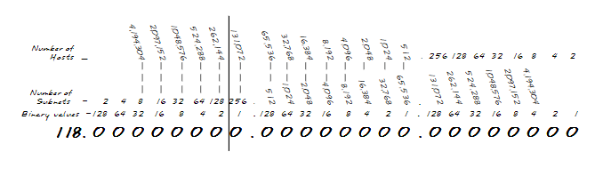

Pág. 16:
Number of needed usable subnets: 60
Number of needed usable hosts: 1000
Network Address: 128.77.0.0
Address class: Classe B
Default subnet mask: 255.255.0.0
Custom subnet mask: 255.255.252.0
128+64+32+16+8+4=252
/16+6=22
Total number of subnets: 62
Number of usable subnets: 60
Total number of host addresses: 1002
Number of usable addresses: 1000
Number of bits borrowed: 6

